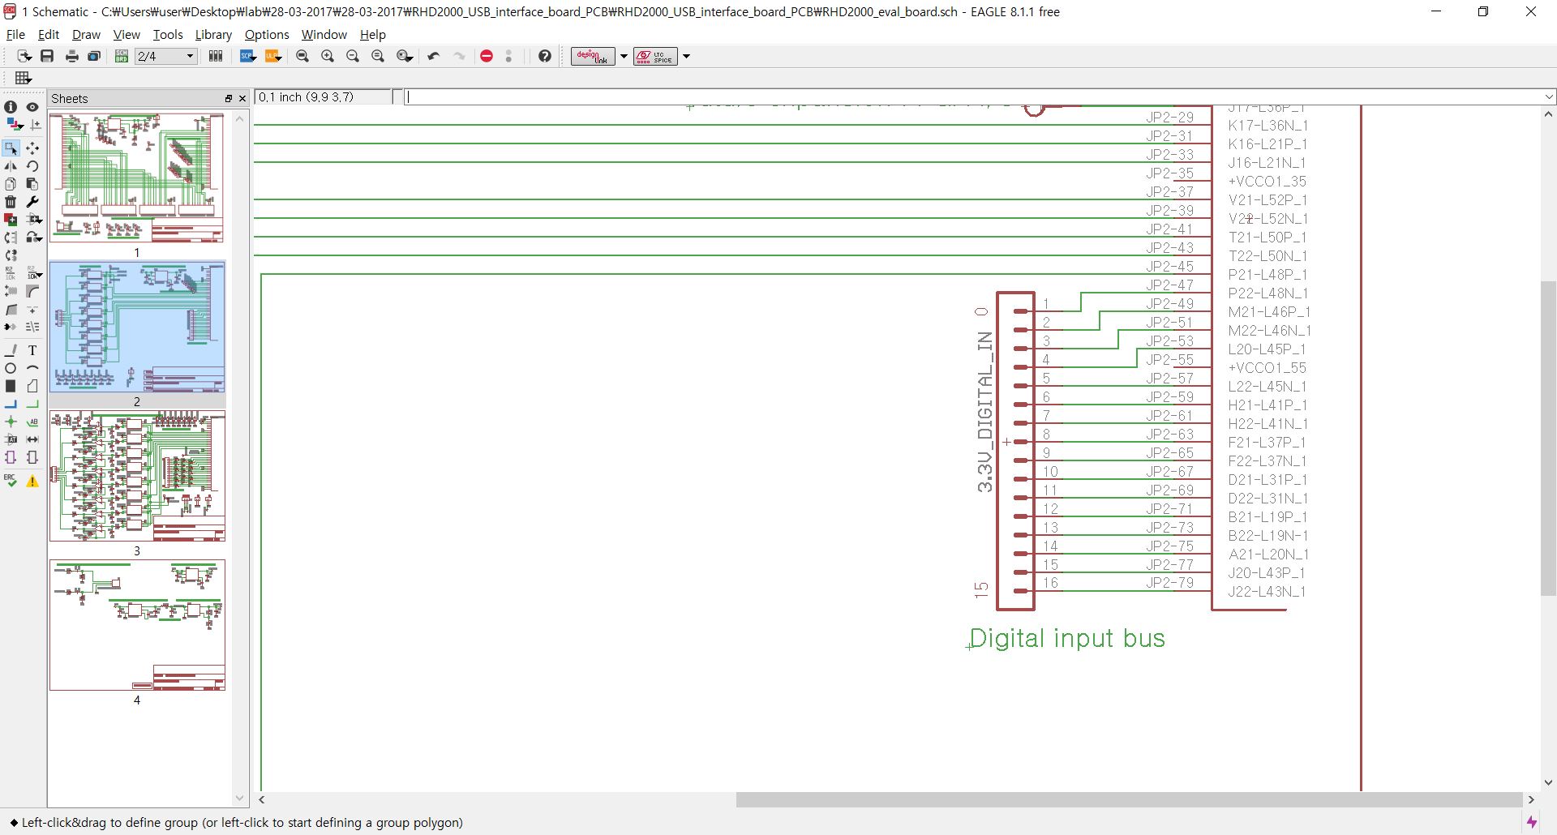

RHD2000 Intan schematics

“JP2- ‘#’“corresponds to “JP1B- ‘exactly the same #’” in BRK board.